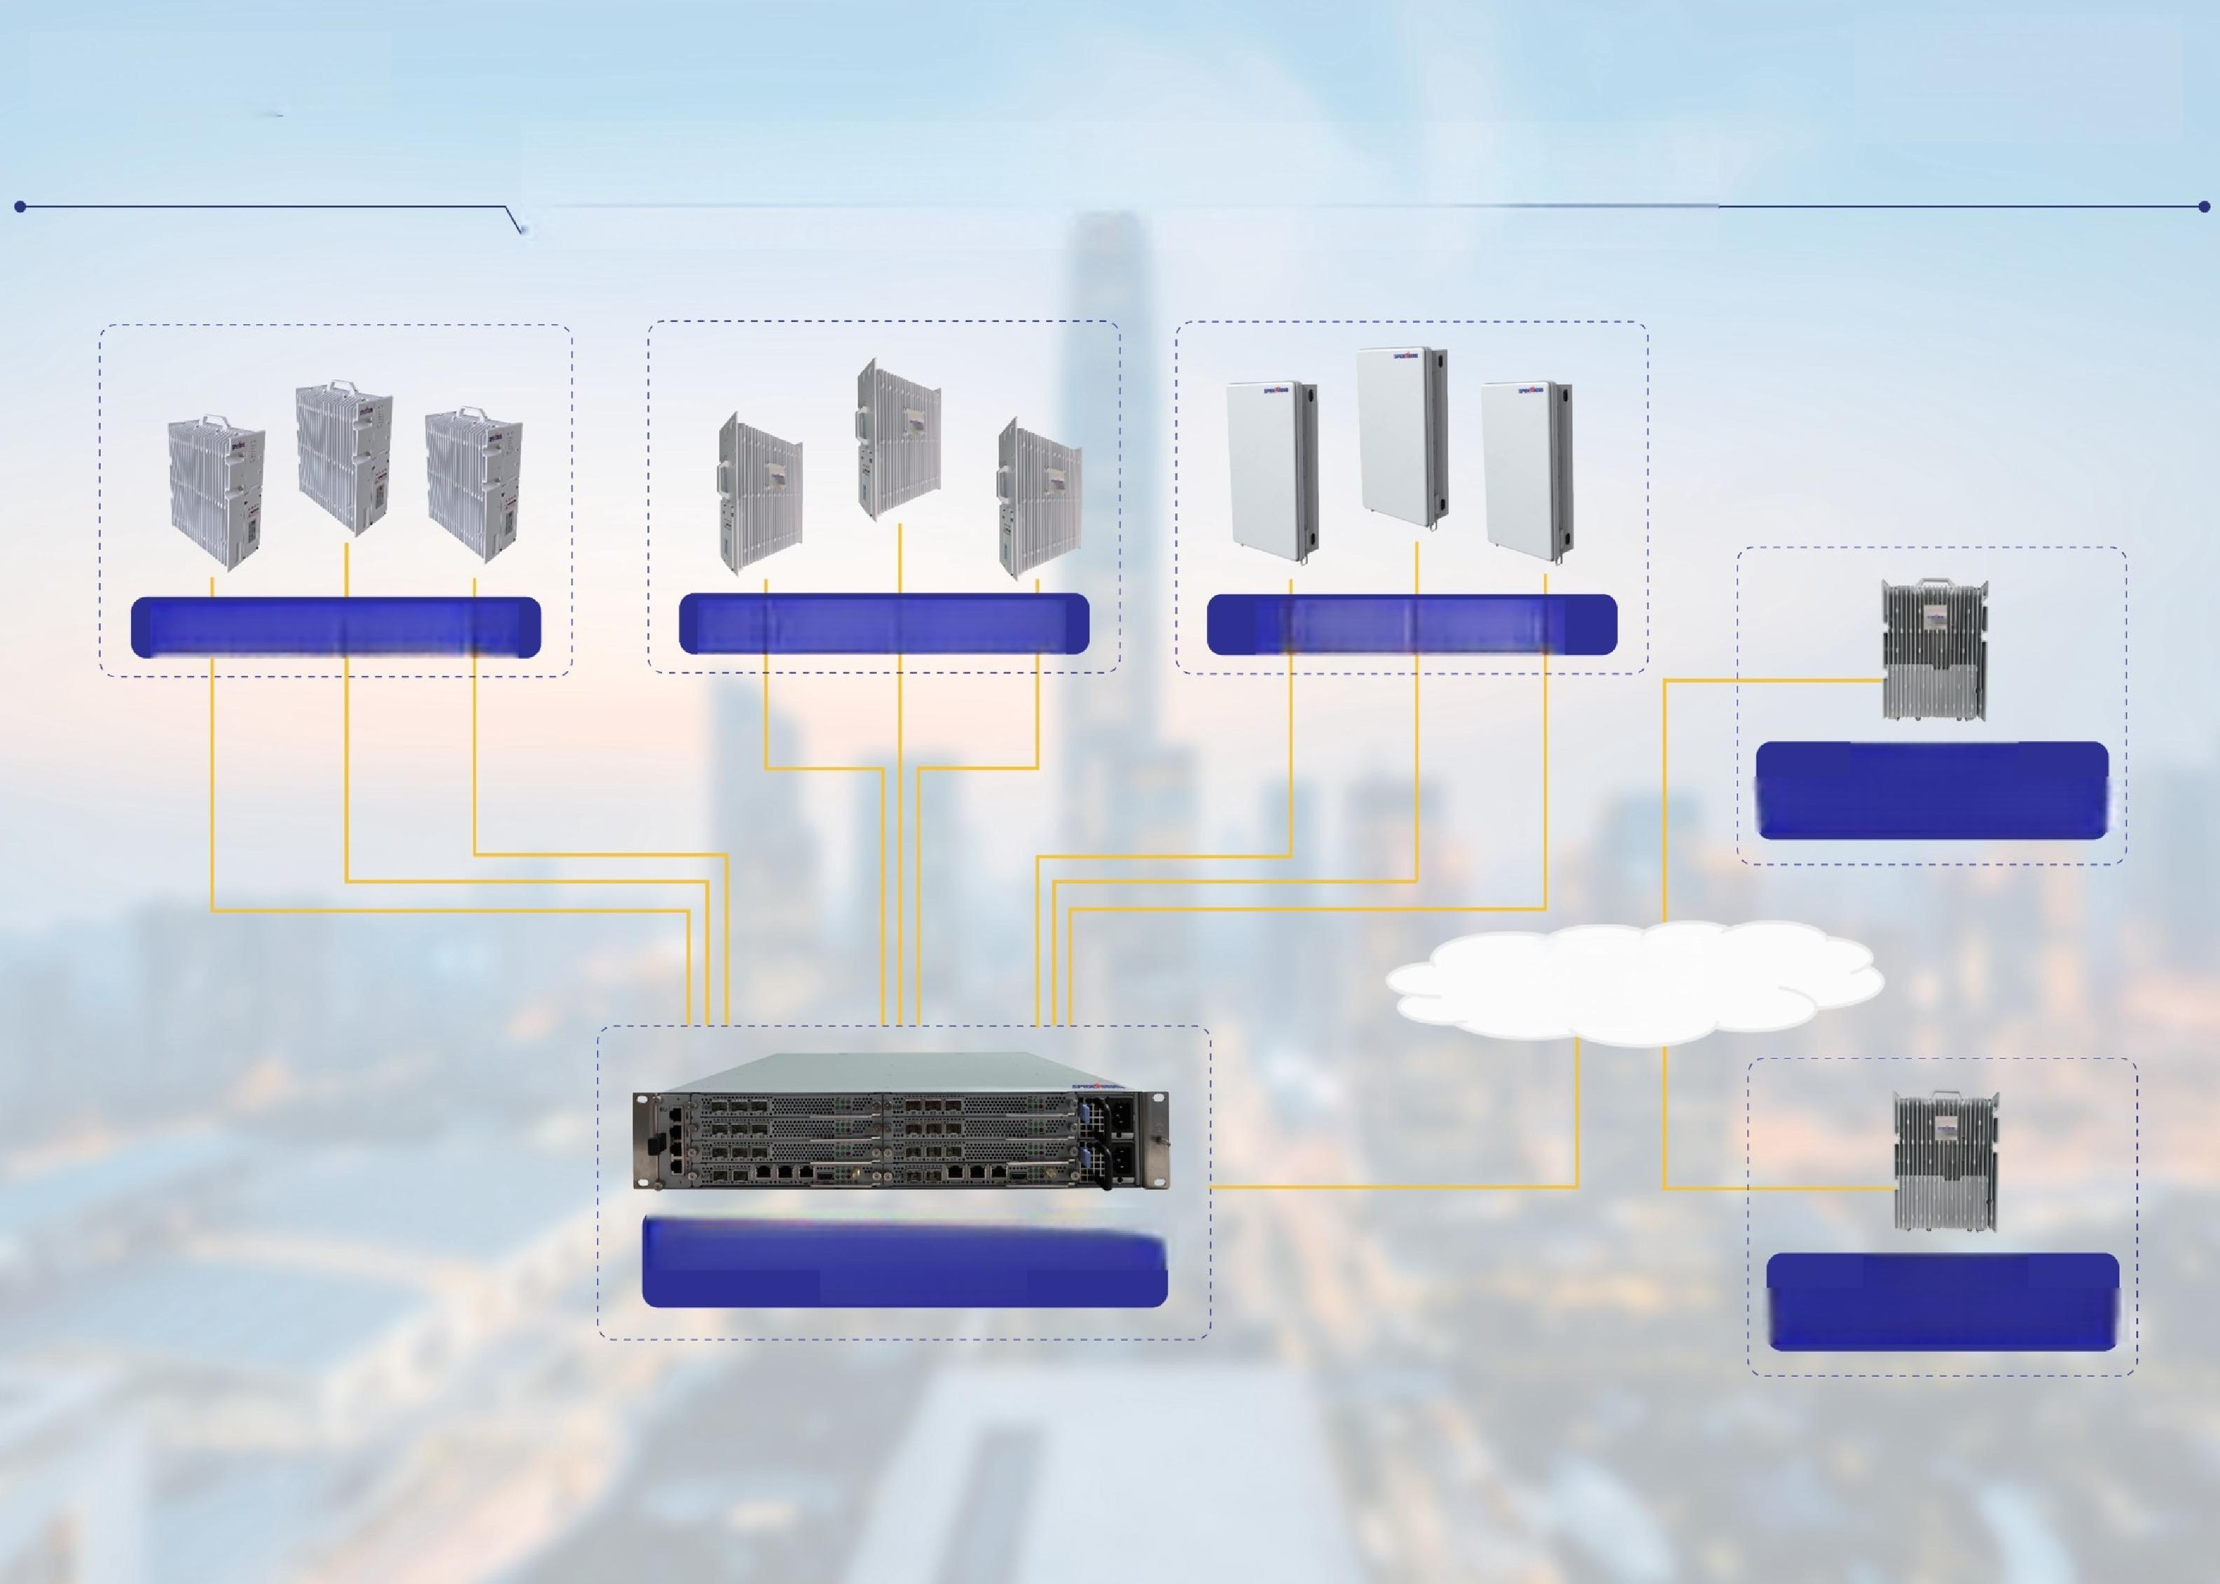**MEGACELL**

—BY SPIDERADIO

**Public Network,Dense Urban Coverage**

**Outdoor 2G+4G RRU Outdoor 4G/5G RRU Outdoor 5G AAU**

**Outdoor**

**4G Integrated eNB**

**Converged**

**Core/IMS**

2G 4G 5G Multi Technology Macro BBU

**Outdoor**

**5G Integrated gNB**