

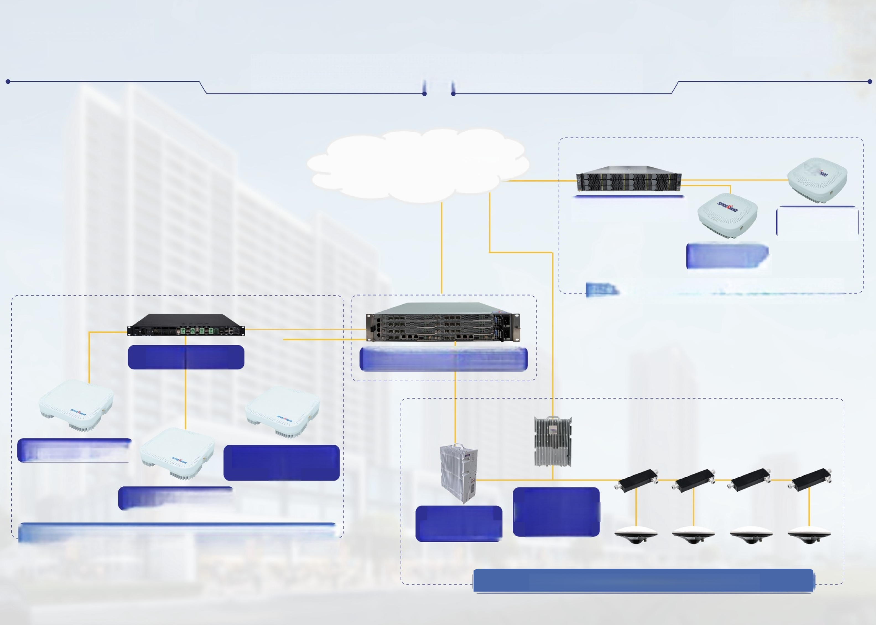**DEEPCEL!**

—BY SPIDERDI0—

**Public Network,Indoor Coverage**

**Converged Core/IMS**

**4G/5G Gateway** Indoor 5G

Pico Cell

Indoor 4G

Pico Cell

**Office,Restaurant,Supermarket**

**4G/5G Hub 4G/5G Dual-mode BBU**

**Indoor 4G RRU**

**Indoor 4G/5G**

RRU

**Indoor 5G RRU**

Outdoor Integratec

Outdoor

eNB/gNB

4G/5G RRU

**Mall,Office Building,Airport**

**Shopping**

**Re-use DAS,Basement,Tunnel**