

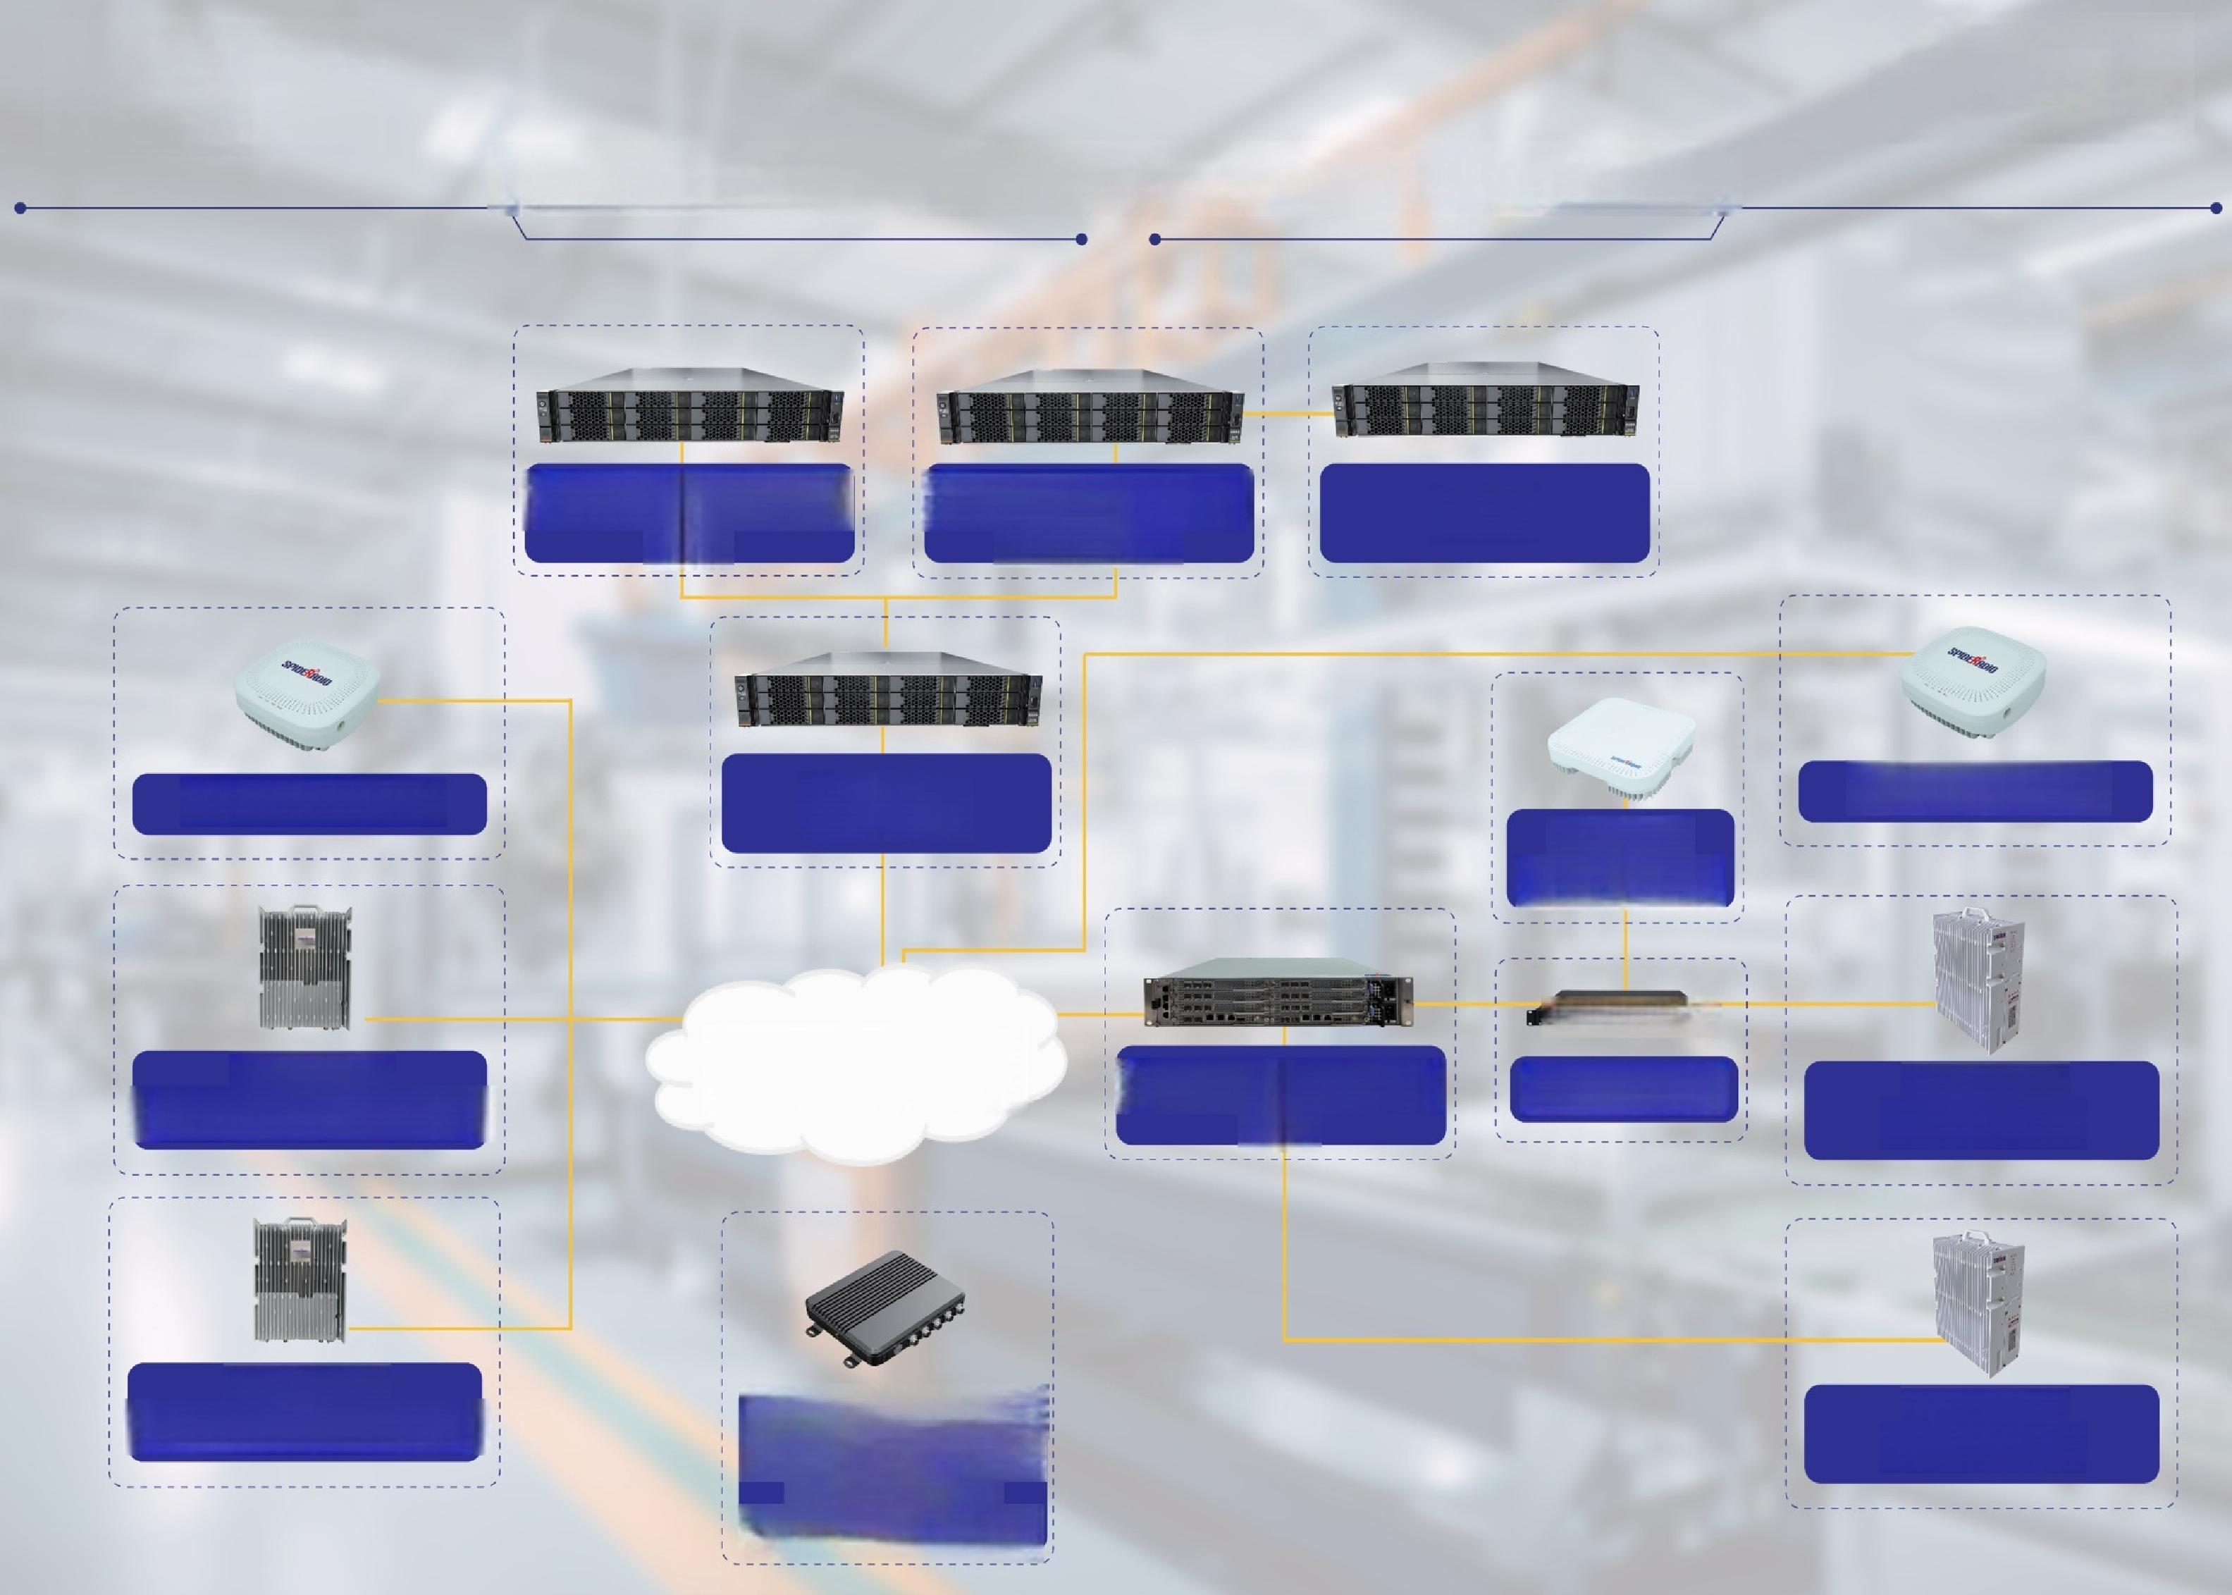**Industrial Private Network End to End Solution**

4G 5G Converged NMS

4G 5G Converged Core/IMS

BOSS

Gateway

5G Pico Cell

**4G Pico Cell**

Indoor

4G 5G RRU

日 a1

**Transport** 4G 5G Dual-mode BBU

Outdoor

Outdoor

4G 5G RRU

4G Integrated eNB

4G 5G Hub

**Outdoor**

Industrial CPE

**5G Integrated gNB**

Outdoor

4G 5G RRU

-eMBB,RedCap

(Any band,

high tx power)