

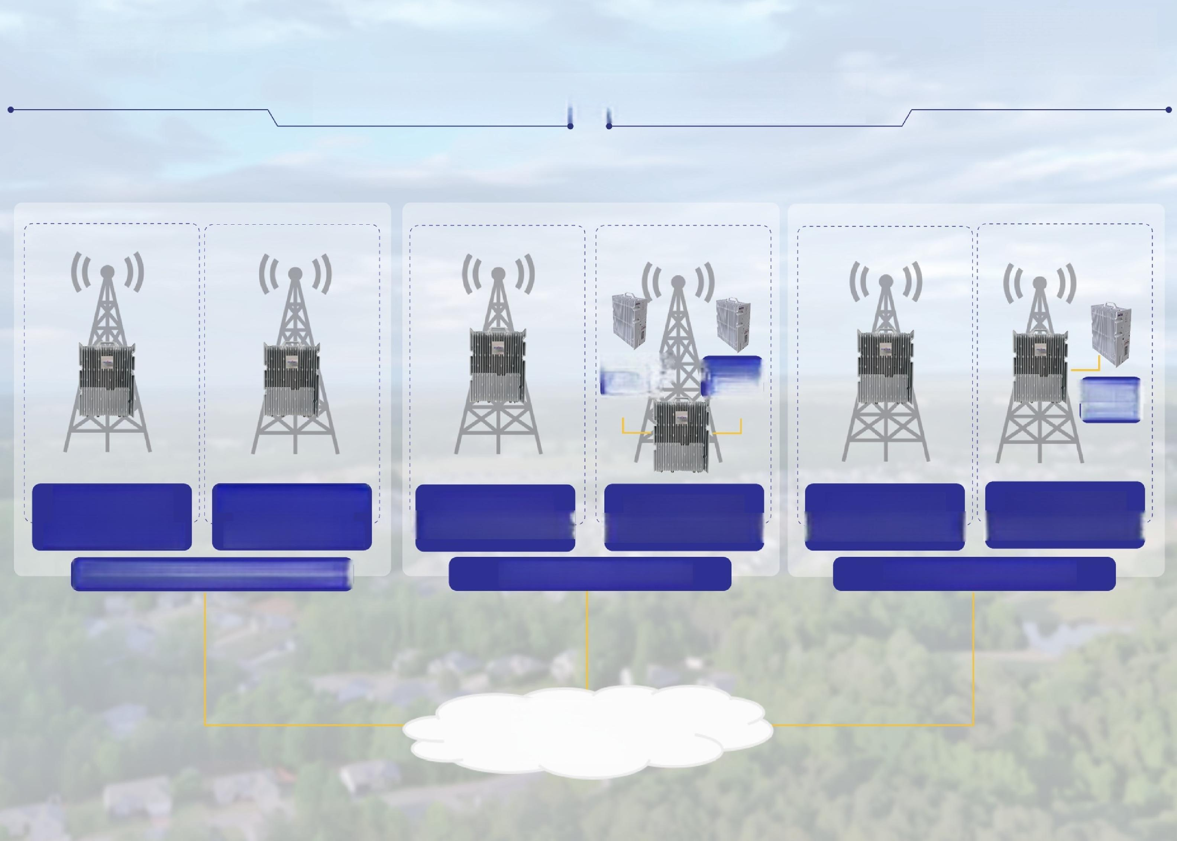**EASYCELI**

—BY SPIDER ADIO—

**Public Network,Suburbs Coverage**

**Outdoor**

Outdoor

4G RRU

4G RRU **Outdoor**

5G RRU

**In** **d** 5**g**G**NB** Int 5gGNB

Outdoor 2G **Outdoor 2G+4G**

Outdoor Integrated

4G

Integrated Integrated

Outdoor Integrated

4G

eNB

eNB

Base station Base station

**2G /2G&4G Macro Solution**

**5G Macro Solution**

**4G Macro Solution**

**Converged Core/IMS**