

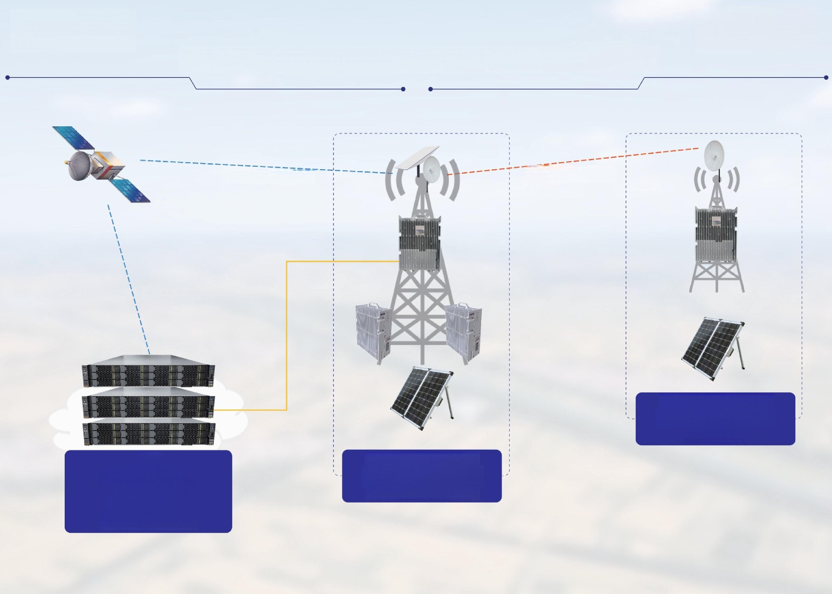**RuralArea Mobile Networks End to End Solution**

**WiFi Bridge**

**Satellite**

**Link**

**Satellite Link**

***2G/2G+4G 4G/5G***

**Integrated Base**

Station

**BSC**

**Core Network**

**Cloud NMS**

**Cloud BOSS**

**as a Service**

***2G/2G+4G 4G/5G***

Integrated Base

Station +RRUs