

**AI Powered NMS and BOSS**

**SpiderNMS**

**Multi-Generation Network Management:2G/4G/5G base stations,**

Core, and CPE

TR-069&ORAN Southbound APIs

Flexible Northbound API Integration

Al-Powered Intelligent Assistant

Real-Time Monitoring Reliability

Centralized Configuration Management

Interactive KPI Dashboard

**Correlated Alerting &Event Handling**

**Advanced Log Analytics**

**Geo-Redundant High Availability**

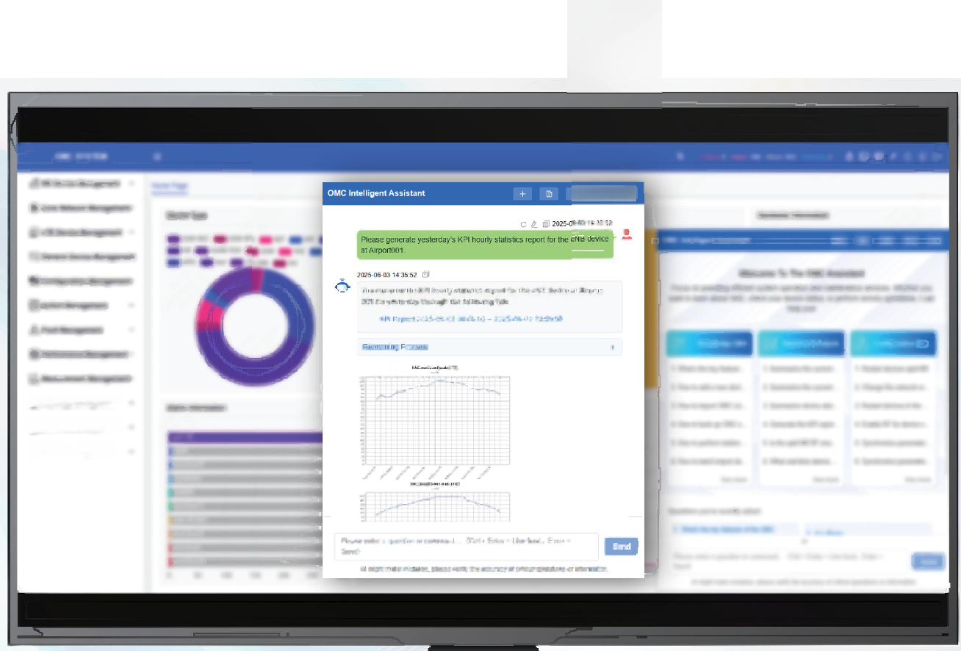

口 ×

**SpiderBOSS**

**Unified Billing Engine**

**Customer Lifecycle Management**

Services &Packages Management Invoicing &Payment Processing Southbound Systems Integration

Rapid Service Provisioning

Revenue Assurance &Optimization

**Real-Time Usage Analytics**

Al-Powered Intelligent Assistant

**Enhanced Customer Experience**