Rules & Regulations for using the VIP Drop-off Area
Welcome to the MWC25 Barcelona VIP Drop-off Area!
The VIP Drop-off Area is exclusively reserved for the drop off of MWC25 Barcelona high-profile attendees, including CEOs and C-level executives (VIPs).
Our priority is to provide a seamless and efficient experience for all VIPs utilizing this designated area. We aim to maintain smooth traffic flow both around the MWC venue and within the dedicated VIP Drop-off Area and Car Park E.
Please make sure to review and comply with these rules and regulations, and ensure they are shared with all your drivers, who must also comply with them.
To confirm your agreement to abide by these rules and regulations, please provide your contact information and sign on the last page.
Thank you for your cooperation.

MWC25 Barcelona VIP Drop-off Area Rules & Regulations

- Obtaining the VIP Car Sticker:

- Requirement: Each vehicle requires an official VIP Car sticker.
- Acquisition: Request the sticker through the Online Event Manual by logging in to your account.
- Stickers Distribution:
  - Date: Saturday 1 March & Sunday 2 March 2025
  - Time: 10:00 – 14:00
  - Location: Fira Gran Via – Car Park E (c/ Botànica)
- Access to Car Park E to collect VIP Car sticker: Enter via the car ramp or stairs for pedestrians.
- Important Notes:
  - Stickers are non-transferable and assigned to specific clients.
  - Place the sticker visibly on the bottom right corner of the windscreen for easy scanning.
  - No stickers will be issued after the event begins.
  - GSMA reserves the right to withdraw car stickers to a driver found to be in breach of these rules & regulations.

- Vehicle Restrictions:

- The VIP Drop-off Area is strictly reserved for Limousines, Sedans and Minivans up to 9 seats.
- Larger vehicles must use the Private Bus area on c/ Salvador Espriu.
- The only way to access the VIP Drop-off Area is through Car Park E, located in front of Hall 6 on
c/ Botànica. No access from the c/ Metalúrgica roundabout will be allowed.
- VIP Drop-off Area operating hours:
  - Monday 3 to Wednesday 5 March: 07:00 – 20:00
  - Thursday 6 March: 07:00 – 17:00

- Car Park E Usage

- Car Park E offers direct access to the VIP Drop-off Area and a short-term waiting area.
- Car Park E is not a permanent car park area .
- Upon accessing car park E, the VIP sticker will be scanned.
- When exiting the car park E, the VIP sticker will be scanned again.

- Staying in Car Park E:

- It is crucial to maintain decorum and adhere to the following regulations:

- Never leave your cars unattended.
- Respect the cleanliness of the area.
- Circulate within the speed limitation established for the area.
- Follow the instructions given by the staff managing the area.

- If any of these rules are not followed, the staff has the right to withdraw your sticker.

- Inside the VIP Drop-off Area:

- All drivers should drop off and pick up their attendees only in this area.
- At both the entrance and exit, the VIP Car sticker will be scanned to monitor the time each vehicle spends in the area.
- Pick up: Attendees should wait exclusively inside the venue and only approach drivers within the designated VIP Drop-off Area. Please meet the drivers at one of the numbered slots to expedite loading.
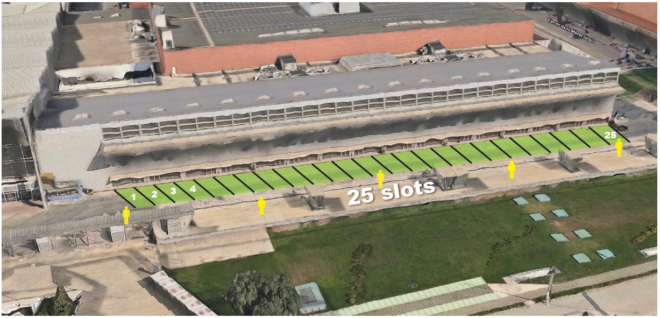
- Drop off: Once the drop off is complete, the driver must leave the area and not return until they have received a call from their client indicating they are ready to depart.

- New for MWC25 Barcelona:

- This area is designated for quick pick-up and drop-off only. Please limit your stay to accommodate others:
  - 5 minutes in the morning (07:00 to 13:00)
  - 10 minutes in the afternoon (13:00 to 20:00)
- This area will be managed by onsite staff who will monitor waiting times. Non-compliance with the time limits may result in drivers being asked to leave the area.
- If a driver exceeds the time limit, after being warned by onsite staff, they will receive an email notification. Repeated violations will be considered a breach of these rules and regulations and may lead to the withdrawal of the VIP sticker.
- Our onsite staff are dedicated to providing a positive and efficient experience. Please work with them to ensure a smooth operation.

Additional Notes for Drivers:

- At MWC25 Barcelona, drivers do not need a badge to enter the VIP Drop-off Area by car, but they will be asked to stay inside the car at all times.
- Drivers must respect the speed restrictions in this area and follow any directions given by the managing staff; failure to do so may result in loss of access to the VIP Drop-off Area.

- Outside the VIP Drop-off Area:

- It is prohibited to stop, drop off, wait, or pick up any person next to the Halls or in any other area next to the Venue other than the VIP Drop-off Area accessible via Car Park E.
- Due to security and traffic restrictions, local police will not allow any parking or cars waiting in streets around the Venue. VIP Cars must wait inside Car Park E (short stay) or at other locations away from the Venue.
- Drivers must follow all instructions from the traffic police. Traffic conditions are complicated due to the high volume of vehicles around the Venue. Please be as cooperative as possible.
- Do not wait at the taxi ranks and watch out for pedestrians.

- Within Barcelona City:

- VIP cars cannot use the taxi or public bus lanes in Barcelona.
- It is also prohibited to stop, drop off, wait, or pick up any person at the taxi ranks in Barcelona.

Declaration of Compliance with the MWC25 Barcelona VIP Drop-off Area Rules and Regulations.
I, [Full Name of Authorized Representative], representing [Company / Exhibitor Name], hereby confirm that I have read, understood, and agree to comply with the MWC25 Barcelona VIP Drop-off Area Rules and Regulations
I understand that it is my responsibility to ensure that all drivers hired through my organization are:

- Familiar with these rules and regulations.
- Agree to abide by these rules and regulations.

I acknowledge that GSMA reserves the right to withdraw the VIP Car sticker from any driver who fails to comply with these rules and regulations.

Company / Exhibitor: _____________________________________________________

Company / Exhibitor Contact Person: _______________________________________

Phone Number: _________________________________________________________

Car Company (if applicable): ______________________________________________

Date: _________________________________________________________________

Signature: _____________________________________________________________

Send this document back to bnetwork: limo@bnetwork.com

For more information on how we process exhibitors and contractors’ personal information at MWC25 Barcelona, please see our privacy notice here.

